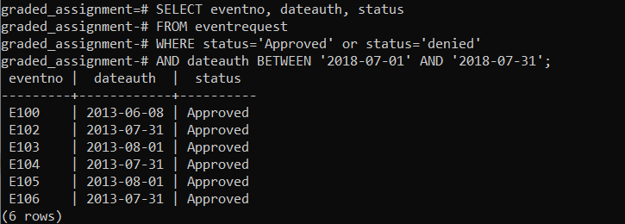

SELECT eventno, dateauth, status

FROM eventrequest

WHERE status != 'Pending'

AND dateauth BETWEEN '2018-07-01' AND '2018-07-31';